GIST produces 4 winners for science and technology promotion award

- Commemorating the 2023 Science and Information and Communication Day...
- Prime Minister Citation (Professor Chul Han Song, Bongjin Simon Mun), Minister Citation (Professor Jaeyoung Lee, Senior Researcher Chang Lyoul Lee)

▲ Picture

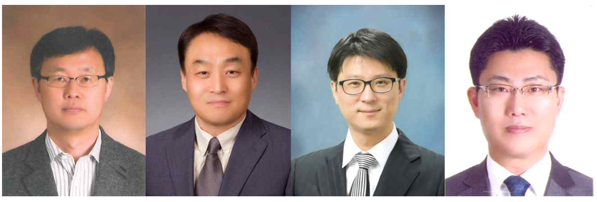▲ From left (Prime Minister’s Commendation) School of Earth Sciences and Environmental Engineering Professor Chul Han Song, Department of Physics and Photon Science Professor Bongjin Simon Mun, (Minister’s Commendation) School of Materials Science and Engineering Professor Jaeyoung Lee, Advanced Photonics Research Institute Senior Researcher Chang Lyoul Lee

On the occasion of the 56th Science Day (4.21.) and the 68th Information and Communications Day (4.22.), GIST (Gwangju Institute of Science and Technology, Acting President Raekil Park) professors and a researcher were honored with a national award for their contributions to the promotion of science and technology by receiving the Prime Minister's Commendation and Minister's Commendation.

The winners were School of Earth Sciences and Environmental Engineering Professor Chul Han Song, Department of Physics and Photon Science Professor Bongjin Simon Mun, (Minister’s Commendation) School of Materials Science and Engineering Professor Jaeyoung Lee, and Advanced Photonics Research Institute Senior Researcher Chang Lyoul Lee.

School of Earth Sciences and Environmental Engineering Professor Chul Han Song was awarded the Prime Minister’s Commendation for Science and Technology Promotion in recognition of his contribution to developing a Korean-style air quality prediction modeling system and establishing a foundation for innovation in the field of atmospheric environment. Professor Song has contributed by responding to pending air environment issues, such as serving as a member of the National Climate Environment Council under the direct control of the President and as the head of the National Strategic Fine Dust Project Group.

Department of Physics and Photon Science Professor Bongjin Simon Mun was recognized for his efforts in basic scientific research to create world-class research results and to promote domestic research capabilities to the world by conducting active international joint research with researchers in the United States, Japan, France, and Switzerland, and he received the Prime Minister's Commendation for Science and Technology Promotion. Professor Mun has contributed to the development of the field of physics in Korea, serving as a working-level director at the Korean Physical Society for 10 years.

In addition, the Minister of Science and Technology Promotion award was given to △ School of Materials Science and Engineering Professor Jaeyoung Lee who contributed to the development of technologies related to tissue engineering, stem cell engineering, cell/drug delivery systems, and bioelectrode materials, as a leading researcher in the field of electrically conductive biomaterials at home and abroad and △ Advanced Photonics Research Institute Senior Researcher Chang Lyoul Lee was selected for contributing to the development of domestic semiconductor technology by developing basic source technology and spreading achievements in the field of organic/inorganic optoelectronic devices.

The Ministry of Science and ICT is rewarding those who have contributed to the development of science and technology in order to inspire pride and honor and boost morale of scientists and engineers on Science Day and Information and Communication Day every year. The 2023 Science and Information and Communication Day ceremony was held at the Korea Science and Technology Center on April 21 at 2:30 p.m.



