**“Improving the Productivity of Eco-Friendly ‘Green Hydrogen’”**

**Development of Photoelectrode with Greater Efficiency and Lifespan**

**- GIST Prof. Lee Sang-han’s joint research team’s work, published “Advanced Energy Materials.“**

**- Breaking away from the traditional method... Developed a world-class photoelectrode by applying new technology that suppresses energy loss.**



▲ (Top) Prof. Lee Sang-won of GIST, Prof. Seo Jang-won of KAIST. (Bottom) Dr. Choi Ho-jung of the Department of Materials Science and Engineering, GIST; Dr. Kim Yeong-yun of the Korea Research Institute of Chemical Technology, and Dr. Seo Se-hun of the Lawrence Berkeley National Laboratory.

GIST (Gwangju Institute of Science and Technology, President Lim Kichul) Prof. Lee Sang-han of the Department of Materials Science and Engineering along with KAIST Professor Seo Jang-won and others have applied a new technology that suppresses the loss of photogenerated carriers* to develop an organometal halide perovskite photoelectrode (hereafter, referred to as “perovskite”*) that exhibits world-class efficiency and life.

* Photogenerated carriers: When a semiconductor photoelectrode receives light, electron-hole pairs that are generated when a substance absorbs light energy are called photogenerated carriers. In a photoelectrode, or solar cell, the loss of photogenerated carriers must be minimized to achieve high photo-efficiency.

** Perovskite: An organic-inorganic compound with a crystal structure of ABX3, which can absorb a wide range of light and generate a large amount of photo-generated carriers. It is in the limelight as the next-generation optical semiconductor.

As carbon neutrality is drawing attention worldwide today, hydrogen energy is an eco-friendly energy that must be produced. However, since most hydrogen is produced from fossil fuels and emits carbon dioxide as a by-product, technology for producing “green hydrogen” produced from sunlight is absolutely necessary.

When producing green hydrogen using sunlight, the photoelectrochemical water splitting* method is commonly used. The photoelectrode absorbs sunlight to generate photogenerated carriers, which decompose water to produce green hydrogen. The loss of photogenerated carriers in this process reduces the efficiency of the photoelectrode.

* Photoelectrochemical water splitting: An eco-friendly green hydrogen production method that provides semiconductor photoelectrode to an electrolyte. When light enters a photoelectrode, photogenerated carriers (electron-hole pairs) are produces the holes are utilized in oxygen-inducing reactions, and electrons are utilized in hydrogen-inducing reactions.

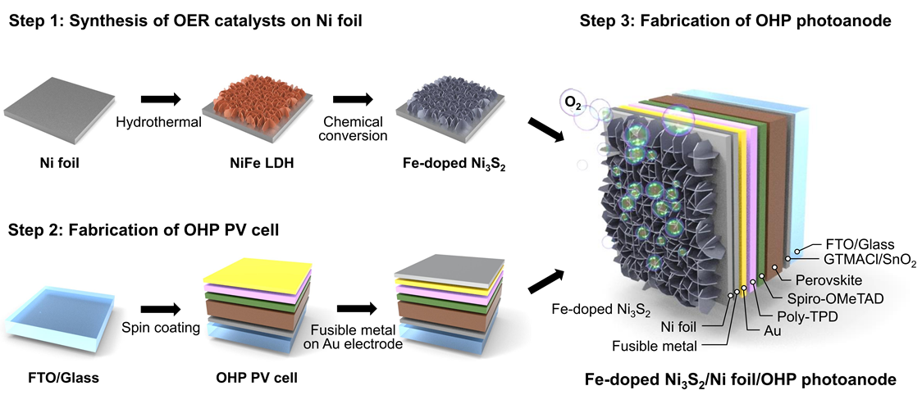

▲ Schematic diagram of perovskite photoanode combined with Fe-Ni3S2 synthesized on nickel foil as a protective layer.

The research team succeeded in developing a world-class perovskite photoelectrode by applying two key technologies that suppress the loss of photogenerated carriers.

First, glycidyltrimethylammonium chloride, a single-molecular organic material*, was applied to the tin oxide of the photoelectrode to control the defects between the tin oxide and the perovskite border. As a result, the team was able to produce the occurrence of photogenerated carriersbeing unable to be converted into electric energy and emitted as thermal energy.

Second, the nickel-iron double layer hydroxide catalyst synthesized in the nickel foil protective layer of the photoelectrode was replaced with an iron-doped nickel sulfide catalyst to facilitate the water decomposition reaction between the photoelectrode and the electrolyte.

* Single-molecular organic matter: refers to organic molecules with low molecular weight in contrast with highmolecular substances connected through polymerization.

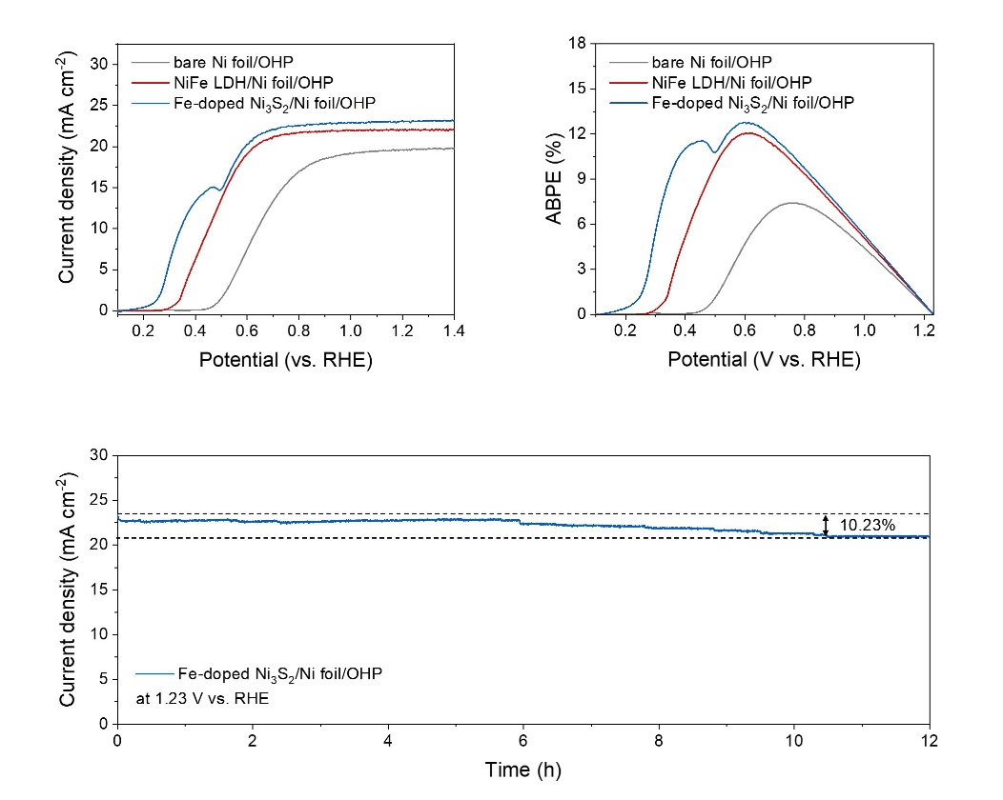

▲ The perovskite photoanode with the loss suppression technology fabricated by the research team achieved high efficiency and stability.

The research team effectively suppressed the loss of internal and external photogenerated carriers by controlling defects within the photoelectrode and facilitating the water decomposition reaction from the outside. As a result, the team not only achieved a world-class photoelectrode efficiency of 12.8% but also obtained high stability with only a 10.2% reduction in efficiency after 12 hours of use.

GIST Prof. Lee stated, “In this research, we broke away from existing methods and applied a ‘less control’ technology to demonstrate the possibility of producing perovskite photoelectrodes with world-class efficiency and stability.” He added, We expect this technology to be applied to next-generation photoelectrodes to enhance hydrogen productivity.“

This research, led by Prof. Lee and jointly participated by Prof. Seo Jang-won of the Department of Chemical and Biomolecular Engineering at KAIST, was conducted by Dr. Choi Ho-jung of the Department of Materials Science and Engineering at GIST, Dr. Kim Yeong-yun of the Korea Research Institute of Chemical Technology, and Dr. Seo Se-hun of the Lawrence Berkeley National Laboratory in the United States. The research project received support from the National Research Foundation’s Future Hydrogen Source Technology Development project, the Senior Researcher Project, the ERC Leading Research Project, and the Korea Research Institute of Chemical Technology’s major institutional project.

The research results were published on June 17 in Advanced Energy Materials, a world-renowned academic journal in the field of energy.