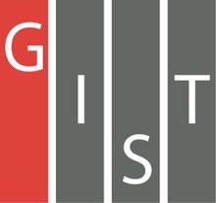

**Gwangju Institute of Science and Technology**

**Official Press Release (https://www.gist.ac.kr/)**

**Section of** Mi-Yeon Kim Nayeong Lee

**Public Affairs** Section Chief Senior Administrator

(+82) 62-715-2020 (+82) 62-715-2024

**Contact Person** Yong-hyuk Choi, Administrator

**for this Article** Section of Public Affairs

(+82) 62-715-2025

**Release Date** 2019.06.19

**GIST is ranked fifth in the world for ‘citations per faculty’ in the 2019/20 QS World University Rankings**

□ On June 19, 2019, QS (Quacquarelli Symonds), a global university evaluation organization in the UK, announced the 2019/20 QS World University Rankings in which GIST (President Kiseon Kim) was ranked third in the world for 'citations per faculty.'

∘ GIST was ranked fifth in the world in the number of papers per professor in this year's assessment of 1,620 universities worldwide. The GIST ranked No. 2 in the world in 2015 and 2016, and ranked No. 3 in the world in 2017 and 2018 and has maintained its No. 1 position in Korea for 12 years.

□ The number of citations per faculty can be used to evaluate both the quantity and the quality of the research capacity of a university. The papers published by the researchers of a university are cited by other researchers in related fields. The higher the score, the greater the impact and significance of the research results.

∘ In contrast to subjective evaluations such as ‘academic evaluation’ and ‘graduation evaluation,’ this is considered the most reliable evaluation because it shows 'objective' data such as the average research results of the university and its influence on other studies in the field.

∘ GIST was first ranked in the top 10 in 2012 after steadily rising in the ranking since it first made the list when it was ranked No. 15 in 2008 (6th in 2010, 4th in 2014, ranked sixth in 2013, fourth in 2014, and 2nd for two consecutive years in 2015 and 2016).

∘ King Abdullah University of Science and Technology in Saudi Arabia was ranked first in the world in 'citations per faculty' followed by the Indian Institute of Science and Technology, Princeton University, California Institute of Technology, and then by the Gwangju Institute of Science and Technology.

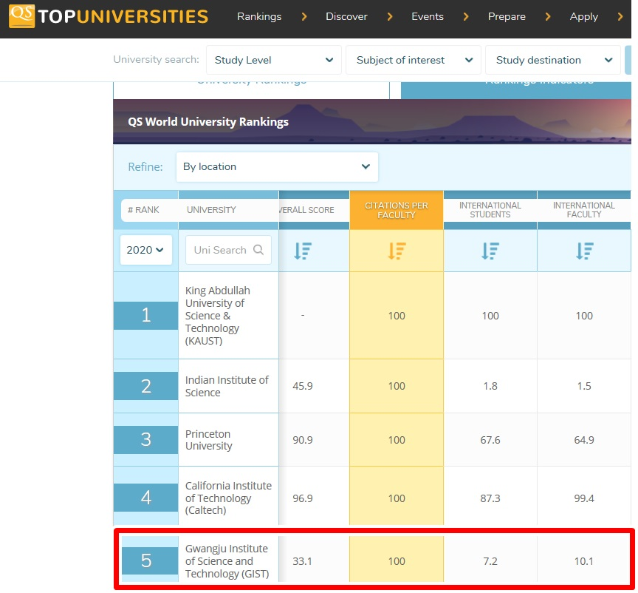

□ GIST’s research capacity has been evaluated as world-class for many years because it has attracted researchers with excellent competence and has created an optimal research environment in which they can engage in research.

∘ To create an environment where professors can concentrate on research, graduate school professors are only required to teach two courses per year to create an environment where they can focus more on research. Professors are also exempt from having to teach courses if they are engaged in large-scale projects.

∘ In addition, GIST has a “Start-up Fund,” which is one of the best in Korea, that allows professors to quickly establish their labs. After becoming a professor at GIST, new professors are exempt from teaching duties for one semester during their first year to help improve the research environment.

∘ If professors achieve excellent results in academic, research, and other activities as a world-class academic researcher, the professor will be awarded as a 'GIST Special Professor or GIST Professor,' which offers a variety of benefits.

∘ Professors with excellent educational and research achievements are offered a “chair” system that allows them to continue their lectures and research even after retirement, thereby giving incentives to excellent professors while supporting students.

□ GIST also recognizes the importance of students as being research partners withs professors, allowing students in the bachelor's, master's, and doctoral programs to participate actively in research while offer various opportunities to improve themselves.

∘ 100% of graduate students participate in research with their advisors in an environment where they can study and research. Undergraduate students can also take part in internships in GIST graduate laboratories at any time. In addition, GIST provides various research opportunities to study with professors at Caltech in America through the 'Caltech SURF Program.'

□ GIST President Kiseon Kim said, "This achievement is the result of research by all members of GIST. Based on GIST's excellent research capabilities, we will successfully lead the 'Artificial Intelligence-based Industrial Convergence Complex Project' with Gwangju Metropolitan City to lay the groundwork for economic growth in the era of the 4th Industrial Revolution in the Jeonnam region, and we will strive to foster new local industries and create more jobs."

⌘