GIST Presents New Interpretation of Quantum Eraser

- Professor Ham Byeong-seung’s team presents an interpretation of the fabricated phenomenon of the quantum eraser through selective observation.
- Advancement in future quantum communications... Published in Scientific Reports, an international journal.

▲ Prof. Ham Byeong-seung (left) and doctoral student Kim Sang-bae of the Department of Electrical and Computer Engineering.

Prof. Ham Byeong-seung of the Department of Electrical and Computer Engineering at GIST (Gwangju Institute of Science and Technology), who is a renowned scholar in the field of quantum memory, presented a new interpretation of the quantum eraser, one of the core phenomena of quantum mechanics.

The quantum eraser in quantum mechanics is one of the thought experiments in quantum mechanics conducted with thoughts in the head, showing the characteristics of wave-particle duality* and the uncertainty principle** of a quantum. It is used to reveal how the act of measuring or monitoring the characteristics of a quantum affects its behavior.

* Wave-particle duality: A quantum as a particle can have a specific position and momentum but can also exhibit characteristics as a wave, and these two characteristics appear mutually exclusive.

** The Uncertainty Principle: It is impossible to measure two physical quantities (position and momentum) at exactly the same time, which means that quantum characteristics cannot be known accurately at the same time.

When the path of a quantum is observed with an optical device, the quantum exhibits characteristics as a particle, but when the path information of the quantum is deleted with another optical device and observed for wave characteristics using a different optical device with the quantum’s path information removed, the quantum exhibits characteristics as a wave. Observing the behavior of the quantum itself changes the characteristics of the quantum, and the causal relationship is overturned by retroactive observation* in which the result affects the cause.Unlike indicators such as academic reputation or graduate reputation, which are conducted through surveys, this indicator is considered to be the most reliable evaluation item in that it shows objective data on research performance and its impact on other research.

* Retrospective observation: Performing at the present time a measurement that changes the state of a quantum that occurred in the past. The result of a measurement has a retroactive effect on the past, and the result affects the cause.

As such, the claim that quantum complementarity* of particles and waves can be determined by delayed choice** after an event occurs is one of the key arguments of quantum mechanics.

* Complementarity: A principle in quantum mechanics, stating that the properties of particles and the properties of waves are complementary and exclusive to each other.

** Delayed Choice: In a quantum mechanical interferometer experiment, it refers to the state where the causality is not satisfied due to having a greater measurement time (usually the length of the interferometer) of an event that had occurred than the point in time that could have been reached at the speed of light.

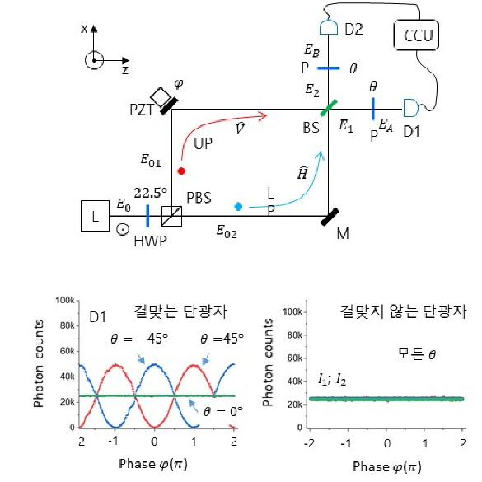
▲ The Quantum Eraser

Through a simple interferometer* experiment, the research team presented a new perspective on interpreting retroactive observations in the quantum eraser as a type of fabricated phenomenon that occurs because only half of the observable events were selectively measured.

* Interferometer: An experimental device that measures the properties of light or system characteristics using the interference of light or other waves. In general, two or more light rays are combined and interact with each other to create an interference.

Regarding the controversy over complementarity in quantum mechanics, the research team expressed that the core of the study is unveiling the illusion of the causal violation caused by specified events selected by the quantum measurement method, even though each event satisfies the causality.

Above all, by experimentally proving that the interferometer must satisfy the coherence* (wave characteristics) of individual photons (particle characteristics), the research team established that the phase relationship** of particles is an essential relationship for the success of the quantum eraser.

* Coherence: The property of waves to show interference. When two or more waves are combined, destructive or constructive interference occurs depending on the phase of the two waves. The better the coherence, the better the interference.

* Phase relationship of individual particles: Refers to the wave function of the particles, which represents their wavelike characteristics. In the quantum eraser experiment, the wave function is adjusted to understand the combination of wave and particle properties of particles.

Prof. Ham Byeong-seung stated, “We can scientifically understand the mystery of quantum entanglement only when we have a clear understanding of complementarity, which is the foundation of quantum mechanics.” He went on to say, “Ultimately, it is expected to become a technological foundation for future quantum communications that are compatible with optical devices and optical communications technology currently in use.”
Led by Prof. Ham and performed by doctoral student Kim Sang-bae, this research was carried out with the support of the ITRC Quantum Internet Project of the Ministry of Science and ICT and the GIST R&D Project. It was published online on June 16 in the international journal Scientific Reports.

