“The Korean Peninsula is facing routine heat waves, and greenhouse gases must be reduced.” GIST - USU (Utah State University) 21st century long-term climate analysis, summer temperatures on the Korean Peninsula are predicted to reach a ‘new normal’ starting in the 2030s

- An international joint research team led by GIST Professor Jin-Ho Yoon conducted a long-term analysis and forecast of summer temperatures on the Korean Peninsula using various data and methodologies... Hotter-than-average summers will become routine after the 2030s.
- “Reducing greenhouse gases is the biggest variable in the new normal era”... published in the international academic journal <Climatic Change>

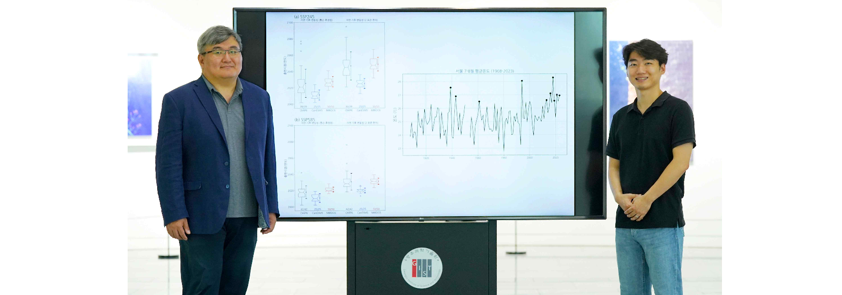▲ (From left) GIST Professor Jin-Ho Yoon and doctoral student Jihun Ryu

s global warming impacts the world's climate, the recent spate of extreme summer temperatures, extreme droughts, and wildfires witnessed around the globe has led meteorologists to suggest that such weather may be the "new normal.

In addition, there are claims that weather prediction will become more difficult if heat waves become routine and a common climate due to global warming.

In response to the question, "When will Korea begin to face a normalized heat wave?" as global average temperatures continue to rise, a joint international research team from South Korea and the United States utilized the Time of Emergence (TOE)* technique to provide a forecast of summer temperatures on the Korean Peninsula.

* Time of Emergence (TOE): This refers to the point in time when climate change due to anthropogenic factors exceeds the natural climate variability. Beyond this point, it is assumed that the climate has deviated from its past average and reached a new normal.

The Gwangju Institute of Science and Technology (GIST, President Kichul Lim) analyzed the '6th Climate Model Intercomparison Project Phase 6 (CMIP6)' by an international joint research team led by Professor Jin-Ho Yoon of the School of Earth Sciences and Environmental Engineering. From the 2030s, the average summer temperature trend on the Korean Peninsula has exceeded natural climate variability. Through this, it is predicted that the Korean Peninsula will enter a ‘new normal’ era in which summer temperatures are hotter than average every year, in other words, heat waves have become routine.

In fact, CBS News recently reported* that the Earth's average temperature for a year from June 2023 to May 2024 was 1.63 degrees Celsius higher than before industrialization.

* 「World hits 12 straight months of record-high temperatures — but as warming continues, it'll be “remembered as comparatively cold”」, June 5, 2024

In the case of Korea, according to the long-term outlook for this year's summer temperature announced by the Korea Meteorological Administration in May, the probability that the average monthly temperature in July and August will be higher than normal is predicted to be 40% and 50%, respectively, while the probability that it will be higher than normal is expected to be higher than normal. The low probability was predicted to be 20%.

Therefore, if the summer temperature on the Korean Peninsula reaches a new normal due to the influence of global warming, the probability that the summer temperature on the Korean Peninsula will be lower than normal will approach 0%. Therefore, there is a need to anticipate this situation in advance and prepare for a climate crisis.

According to the research team, natural variability still plays an important role in summer temperatures on the Korean Peninsula, but as global warming accelerates, summer temperatures are expected to always be higher than the average year from the 2030s onwards. As a result, it is predicted that Korea's summer temperatures will reach a new normal.

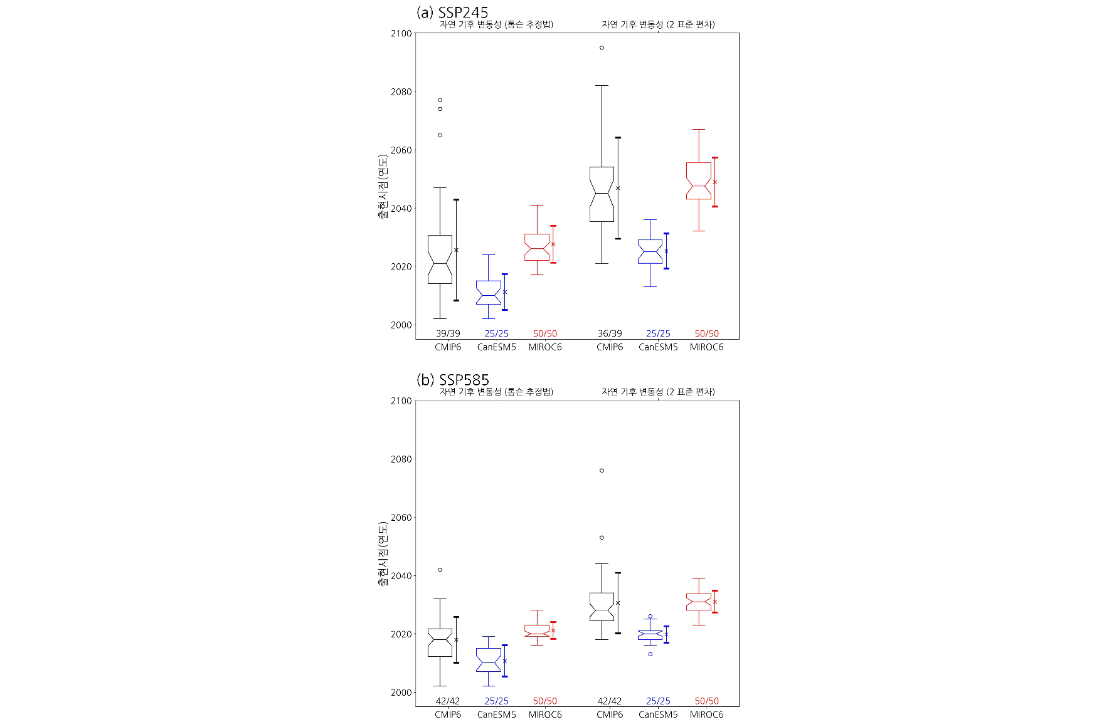▲ Appearance time based on Korea’s highest summer temperature. (a) and (b) show the results of the Shared Socioeconomic Pathways (SSP) 2-4.5 and 5-8.5 scenarios, respectively. The left, bottom, and top axes represent ‘predicted emergence timing’, ‘climate model used’, and ‘method to estimate natural climate variability’, respectively. The numbers below each box plot show the number of total samples for which TOE was predicted before 2100.

However, in a future scenario (SSP2-4.5), where greenhouse gas mitigation policies are implemented and climate change mitigation efforts are taken into account, the new normal is projected to be reached in the mid-2040s or later, and depending on the methodology, the new normal may not be reached at all. This confirms the importance of reducing greenhouse gas emissions, the team explained.

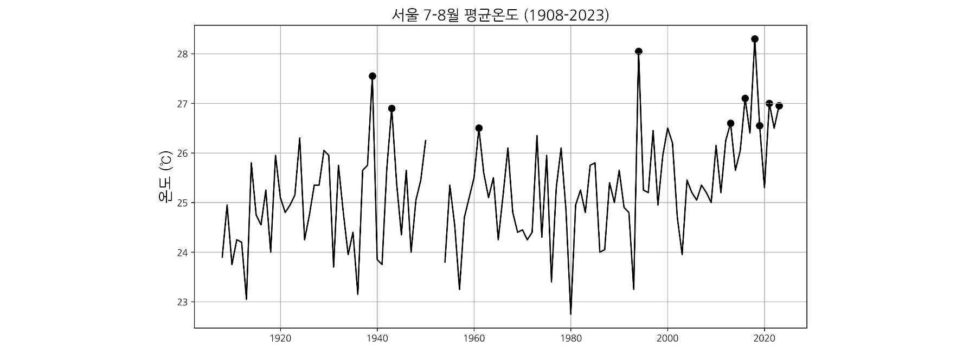▲ Average temperature in July and August at Seoul Observatory. It is a time series from 1908 to 2023, and the left, bottom, and axes represent ‘temperature’ and ‘year’, respectively. The case marked with a black mark represents the 10 hottest times during the entire period, and shows that 6 times have occurred since the 2010s.

Professor Jin-Ho Yoon said, "The emergence timing of our study provides a future point in time when anthropogenic climate change will move beyond its current state. Predicting this point in time will contribute to establishing response strategies to climate change that will hit the Korean Peninsula, including reducing greenhouse gases."

Doctoral student Jihun Ryu (first author) said, "Through this study, identifying when summer temperatures on the Korean Peninsula, which have risen due to global warming, reach a new normal can help prepare for future climate crises."

This research was a joint research led by Professor Jin-Ho Yoon and doctoral student Jihun Ryu of GIST's School of Earth Sciences and Environmental Engineering and participated by Professor Shih-Yu (Simon) Wang of Utah State University with support from the National Research Foundation of Korea's mid-career researcher support project and the overseas excellent scientist attraction project (Brain Pool).

The research results were published online on Thursday, June 27, 2024, in ‘Climatic Change’, a renowned international journal in the field of meteorology. <End>



