GIST develops 'same direction' alkene dihalogenation reaction that reverses the traditional chemical reaction stereoscopic path

- Innovative research results that reverse the stereochemical mechanism that is maintained almost without exception... It is possible to freely combine halogens through sequential reactions, enabling exploration of new characteristics of functional organic materials with stereostructures
- Approaching a new stereochemical area, it is expected to have great academic and industrial impact due to application to various elements other than halogens... Published in the international academic journal 「Nature Communications」

▲ (From left) Professor Won-jin Chung, Professor Jun-Ho Choi, PhD student Hyeon Moon, and PhD student Jungi Jung of the Department of Chemistry

The Gwangju Institute of Science and Technology (GIST, President Kichul Lim) announced that the research team of Professors Won-jin Chung and Jun-Ho Choi of the Department of Chemistry developed a reaction to introduce halogens to alkenes in the “same direction,” reversing the traditional stereogenic pathway of introducing halogens in the “opposite direction.”

The dihalogenation reaction of alkene* is a traditional organic chemical reaction that can be found in chemistry textbooks, and the mechanism by which halogens are introduced in opposite directions on both sides of the alkene has been firmly established. Therefore, a completely new strategy is required to access a different stereogenic pathway.

* alkene: An unsaturated hydrocarbon with one or more double bonds. Due to the double bonds, it has high reactivity and can participate in various chemical reactions. Representative alkenes include ethylene and propylene. They are mainly used as raw materials in the chemical industry and play an important role in the synthesis of plastics, fibers, etc.

* dihalogenation reaction: An organic chemical reaction in which one halogen atom is added to each carbon atom of an alkene.

The reverse alkene dihalogenation reaction is a mechanism that is observed almost without exception, and many researchers have had no choice but to rely on this method for a long time. However, there are still only a few examples of successful stereopathy changes, and its practicality is limited.

Therefore, the development of new mechanisms that can expand the range of reactions is still necessary.

The research team developed a strategy to install two activators using the cycloaddition reaction* that occurs in the same direction of an alkene and to substitute them with halogens. This enabled stepwise halogen introduction, allowing chlorine and bromine to be positionally and site-selectively added to an alkene in a desired combination and order.

* cyclic addition reaction: a reaction in which two unsaturated organic compounds combine to form a ring.

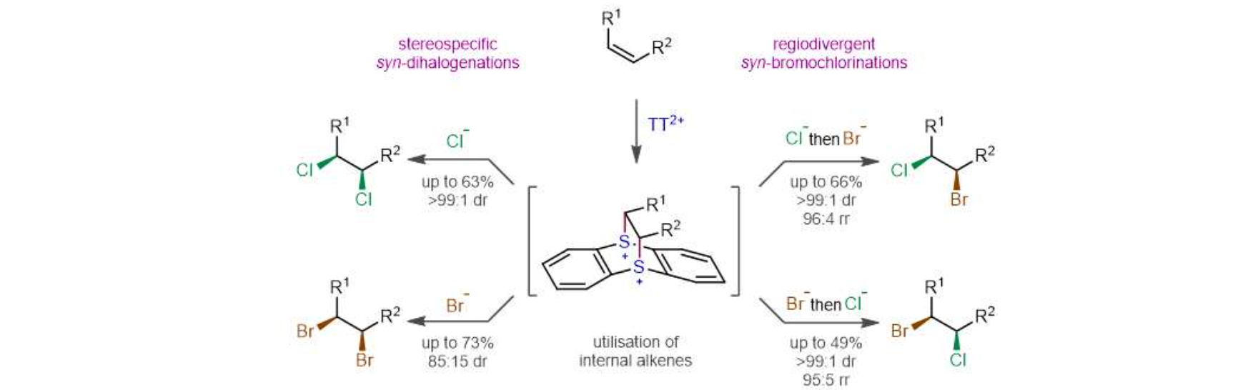▲ Development of same-direction dihalogenation reaction of alkenes using a dual activation strategy: By activating one side of an alkene through a cycloaddition reaction of thianethrene divalent cation (TT2+) and then substituting it twice with a halogen anion, the researchers have implemented the first stereospecific and site-selective same-direction dihalogenation reaction by freely combining chlorine and bromine.

When a highly electron-deficient thianthrene* divalent cation is cyclized to an alkene, two activated sulfonium* cations are formed with the same orientation. However, there has been no case in which this was replaced with another atom while maintaining its stereochemical properties.

* tianthrene: A tricyclic aromatic compound containing two sulfur atoms

* sulfonium: a cation with three organic substituents attached to a sulfur atom

The research team secured the conditions for substitution with halogen without losing three-dimensional information, and developed the first same-direction dihalogenation reaction that freely combines halogens through sequential reactions. In particular, the same-direction addition of different halogens is an original achievement with no precedent.

Natural products with halogen substituents in the same direction are often found, but they are difficult to produce using existing methods, making them difficult to use for studies on physiological activity, etc. However, if the synthetic method developed by the research team is applied, these organic compounds can be produced efficiently, making it possible to explore new properties of functional organic compounds with three-dimensional structures that have not been tested so far.

Professor Won-jin Chung said, "This research achievement suggests an interesting mechanism that reverses the traditional reaction pathway and opens up new stereochemical domains. In the future, expansion into a wide chemical space that includes various elements other than halogens is expected."

This study, supervised by Professor Won-jin Chung (corresponding author) and Professor Jun-Ho Choi (corresponding author) of the Department of Chemistry at GIST and conducted by doctoral students Hyeon Moon (first author) and Jungi Jung (first author), was supported by the Korea Toray Science Foundation and was published online on May 2, 2024, in Nature Communications, an international academic journal ranked in the top 8% in the general science field.



