GIST finds clues to develop effective ‘edible medicine’ in treating skin disease ‘psoriasis’

- Development of substances that inhibit immune-related receptors, published in the international journal “JMC”
- Expectations to develop oral treatments with mechanisms different from existing treatments

▲ (From the left) GIST School of Life Sciences Professor Yong-Chul Kim and doctoral student Bongki Ko

Psoriasis, a chronic skin disease, is an inflammatory disease that occurs due to abnormalities in the immune system. Once it develops, it is difficult to completely cure and is prone to worsening, especially during the dry winter months.

Oral immunosuppressants prescribed to relieve symptoms may cause side effects such as hepatotoxicity and decreased immunity when used for a long period of time. Recently approved and used biological agents are cytokine-neutralizing antibody drugs, which have the disadvantages of relatively high treatment costs and the fact that they can be administered using a syringe. Therefore, there is a need to develop new drugs that have fewer side effects and can be easily administered orally.

The Gwangju Institute of Science and Technology (GIST, President Kichul Lim) announced that Professor Yong-Chul Kim's research team in the Department of Life Sciences has developed a ‘CMKLR1* antagonist’ that will serve as a clue to a new psoriasis treatment.

* CMKLR1 (Chemokine-like receptor 1): It is a G protein-coupled receptor responsible for cell chemotaxis in the immune system.

A high concentration of a signaling substance called ‘chemerin’* exists in the blood and lesions of psoriasis patients, and the receptor for this signaling substance is ‘CMKLR1’. Activated ‘CMKLR1’ causes dendritic cells* to gather in blood vessels around the skin, and these stimulate T cells and keratinocytes, making psoriasis disease more severe.

* chemerin: One of the cell signaling substances, it is related to obesity and diabetes. In psoriasis, various immune cells are induced into lesions in the early stages of the disease, causing psoriasis symptoms.

* dendritic cell: One of the cells that make up the immune system that plays a role in activating other immune-related cells.

The research team proposed developing a drug that could treat psoriasis by inhibiting the activity of CMKLR1. Through the design and synthesis of an optimized compound based on the phenylindazole core skeleton*, we succeeded in developing an antagonist that lowers the activity of CMKLR1.

* phenylindazole core skeleton: This is a standard structure for synthesis, and derivatives with various residues are synthesized using this structure.

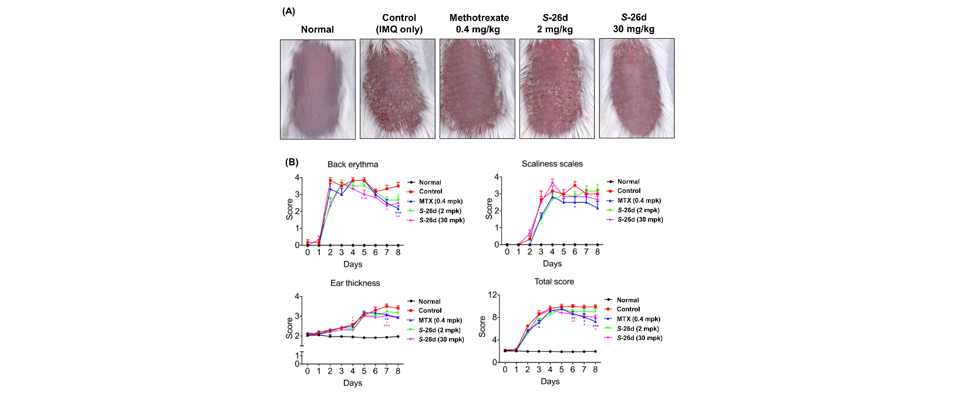▲ Psoriasis alleviating effect of a new antagonist identified in a psoriasis rat model. Figure (A) is a photo taken on the 7th day of each experimental group, compared to the control group and methotrexate, a currently used psoriasis drug. It was confirmed that psoriasis symptoms such as keratin and erythema were greatly alleviated in the group administered 26d, the new antagonist. Figure (B) is a schematic result of the PASI score, a psoriasis evaluation index.

This antagonist strongly inhibited the activity of CMKLR1 even at a very low concentration of 36 nanomolar level. There is an advantage in that it can be developed into an oral preparation as a high absorption rate in the body has been confirmed through oral administration.

The research team confirmed that when the drug was orally administered to a psoriasis animal model (IMQ-induced psoriasis mice), and the keratin, erythema, and thickness of psoriasis lesions were all alleviated. The alleviating effect was also confirmed as the PASI score*, a psoriasis evaluation index, was significantly lowered by more than 30% compared to the control group.

* PASI score (psoriasis area and severity index): This is an index that evaluates the severity of psoriasis by calculating the redness, dead skin cells, and thickness of psoriasis lesions.

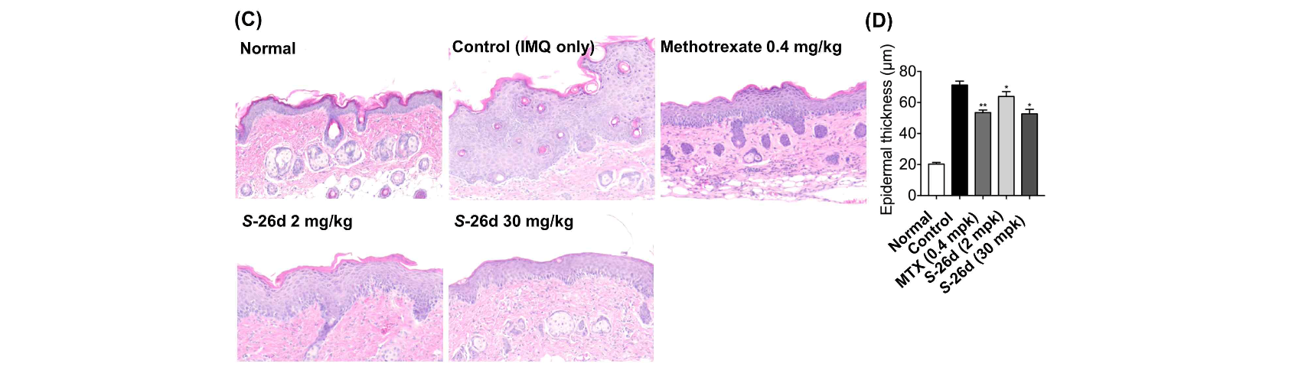▲ Histological analysis results in a psoriasis rat model. Figure (C) shows staining of the back tissue of a rat, showing the recovery of the thickened epidermal layer due to psoriasis induction due to administration of 26d, the new antagonist. Figure (D) schematizes the change in thickness of the epidermal layer.

Professor Yong-Chul Kim said, "Through this study, an antagonist that lowers the activity of CMKLR1 was proposed as a treatment method and as a paradigm for developing new drugs for the treatment of psoriasis, for which there is no effective oral treatment to date. In addition, our research team conducted a molecular modeling study to predict the structure of CMKLR1 and the drug binding mode for the first time, which we expect will be of great help to future CMKLR1-related research."

This research was led by Professor Yong-Chul Kim and Dr. Jung Hyun Han and conducted by doctoral student Bongki Ko with support from the GIST-LG Life Science joint research project and a GIST researcher project. The research results were published online on October 26 in the Journal of Medicinal Chemistry, a prestigious international journal in the field of medicinal chemistry.



