GIST Professor Myung-Han Yoon's joint research team develops electronic devices using sea squirt shell extract... Easily detects bioelectrical signals and expects various uses

- A joint research team of GIST and Inha University developed an eco-friendly organic electrochemical transistor by combining cellulose nanofibers extracted from sea squirt shells and conductive polymers
- Expected to be used in various fields such as healthcare, military clothing, sportswear, and fashion items

▲ (From left) GIST Professor Myung-Han Yoon, Inha University Professor Bong Sup Shim, GIST doctoral student Minhu Huang, and Dr. Seunghyeon Lee of Inha University

In accordance with the recent trend of strengthening environmental regulations, interest in achieving carbon neutrality and developing biodegradable electronic materials and devices is increasing. Meanwhile, a Korea research team developed an eco-friendly electronic device by extracting fiber from marine waste.

The Gwangju Institute of Science and Technology (GIST, President Kichul Lim) announced that a joint research team led School of Materials Science and Engineering Professor Myung-Han Yoon and Inha University (President Myung-woo Cho) Department of Chemical Engineering Professor Bong Sup Shim has developed an eco-friendly fiber-type organic electrochemical transistor* through the composite of cellulose or long fibers extracted from mud crab shells and conductive polymers.

* organic electrochemical transistor (OECT): A type of transistor operating in an electrolyte, a device that switches and amplifies electrical signals by inducing doping/de-doping of a semiconductor layer through an electrochemical reaction between ions present in the electrolyte and the semiconductor layer by an applied gate voltage.

This research outcome is expected to provide an important starting point for the development of eco-friendly wearable or implantable fiber-based electronic devices and sensors in the future by using nanocellulose extracted from sea squirt shell, a renewable and eco-friendly material.

Fibrous organic electrochemical transistors are capable of signal amplification and switching through ion implantation, so they can be implanted in the body or attached to the skin to easily detect various bioelectrical signals from the brain, heart, and muscles, and are used in healthcare and military clothing. It has potential use in a variety of fields, including sportswear and fashion items.

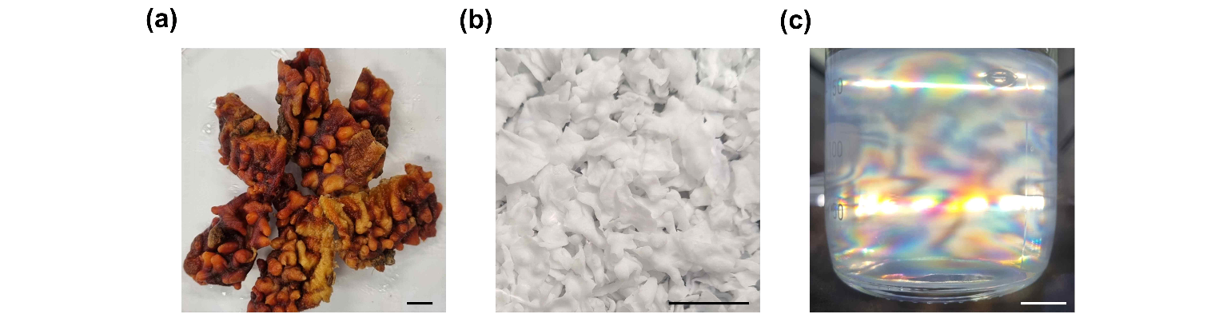▲ In this study, (a) sea squirt shell (b) cellulose extracted from sea squirt shell (c) nanoscale cellulose: the first image shows the dried sea squirt shell, the second image shows the extracted cellulose, and third image is a photo of nanocellulose showing optical properties.

In general, a composite method of mixing two materials with different strengths is used to enhance the mechanical and electrical properties of conductive polymer* materials. It is known that when two substances do not mix well or when attempts are made to enhance the characteristics of one substance, the performance of the other substance deteriorates.

To overcome these limitations, the research team combined highly crystalline and oriented cellulose nanofibers (CNF) with conductive polymer materials (PEDOT:PSS)* to achieve mechanical flexibility and excellent electrical properties by highly aligning them in one direction at the molecular level and successfully developed a material with electrochemical properties.

* conductive polymer: A polymer that has electrical conductivity like a metal conductor. Unlike general organic polymers, it refers to a polymer that simultaneously possesses the electrical, magnetic, and optical properties of a metal or semiconductor.

* PEDOT:PSS (poly(3,4-ethylenedioxythiophene) polystyrene sulfonate): A representative conductive polymer that it is attracting attention as an active layer for organic electrochemical transistors.

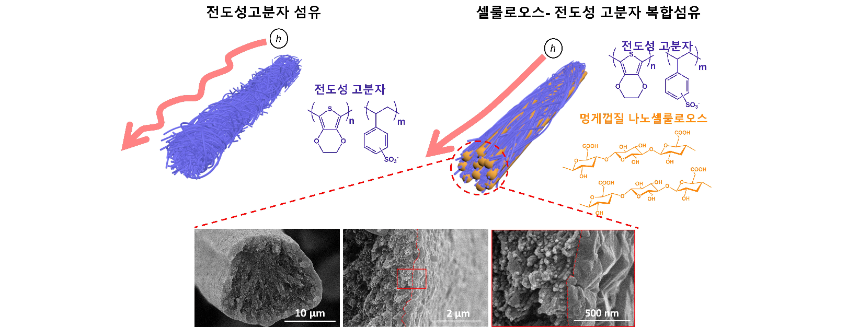▲ Scanning electron microscope image of the highly aligned composite conductive fiber with improved electrical properties developed in this study: By highly aligned in one direction at the molecular level, it can exhibit smoother charge transfer characteristics and excellent electrical and electrochemical properties.

High-performance, flexible, fiber-type electrochemical devices can not only measure bio-signals of humans or animals, but they can also be applied to plants, providing next-generation crop monitoring technology for smart farms that can determine the nutritional status of plants, such as ion changes and moisture content, in real time.

GIST Professor Myung-Han Yoon said, "This research strengthened various properties of engineering polymers using the most abundant natural organic matter on Earth. In particular, improving the electrical properties of conductive polymers by inducing spontaneous structuring of cellulose nanofibers, which are insulators, is of great academic significance as it clearly demonstrates the structuring effect."

Inha University Professor Bong Sup Shim said, "This is expected to play an important role in the development of eco-friendly textile electronic devices that can be worn in the future by using nanocellulose, a biodegradable and renewable material. This will greatly contribute to realizing carbon neutrality and making smart textiles a reality in everyday life."

This research was led by GIST Professor Myung-Han Yoon and Inha University Professor Bong Sup Shim and conducted by GIST Minhu Huang and Dr. Seunghyeon Lee of Inha University with support from the Basic Research Laboratory Project (BRL) of the National Research Foundation of Korea and was published online on November 11, 2023, in ‘Carbohydrate Polymers (IF = 11.2)’, an international academic journal in the field of biomaterials.



