Korean-British research team finds a way to increase power of ultra-powerful lasers

- GIST, UNIST, and Strathclyde joint research team develops new technology key to implementing ultra-powerful lasers, which are 1,000 times more powerful than existing ultra-powerful lasers
- Development of a new method of compressing laser pulses with plasma... Overcoming the limitations of a Nobel Prize-winning idea... Published in <Nature Photonics>

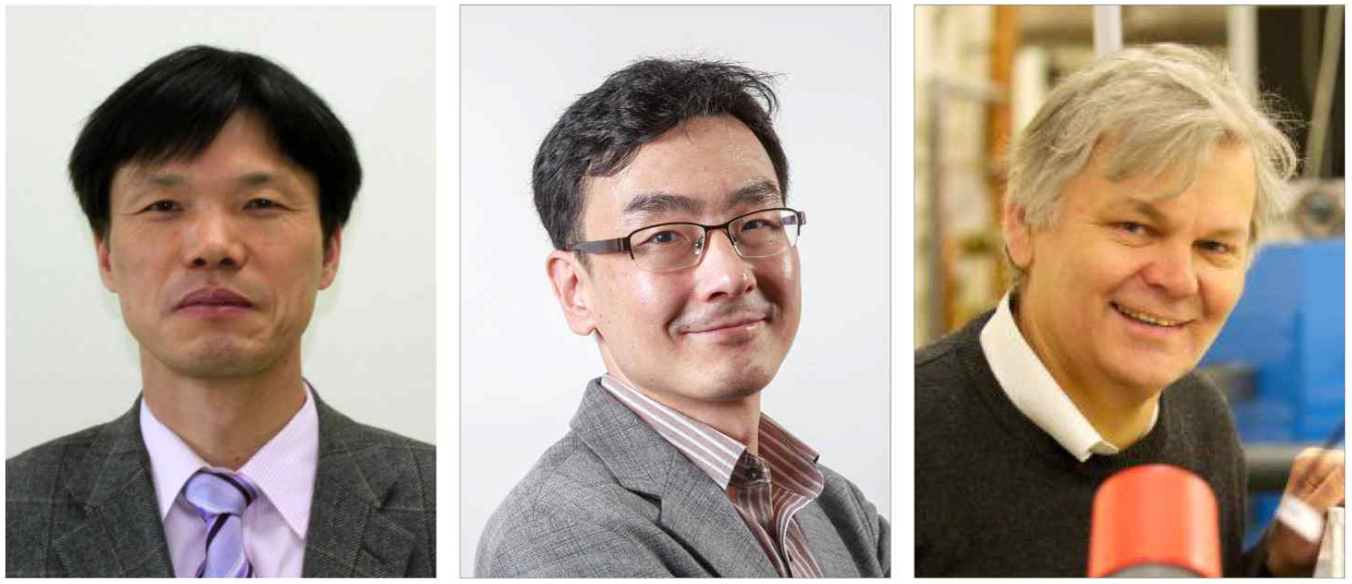▲ (From left) Professor Hyyong Suk of GIST Department of Physics and Photon Science, Professor Min Sup Hur of UNIST Department of Physics, and Professor Dino Jaroszynski of University of Strathclyde Department of Physics

An international joint research team from Korea and the UK has found a new method essential for developing a laser that is much more powerful than the world's highest output laser. This new method is expected to be used not only in basic science such as physics and astronomy but also in advanced technologies such as laser nuclear fusion.

The Gwangju Institute of Science and Technology (GIST) announced that a team led by GIST Department of Physics and Photon Science Professor Hyyong Suk, UNIST Department of Physics Professor Min Sup Hur, and University of Strathclyde Department of Physics Professor Dino Jaroszynski presented a new idea that can create a laser pulse more than 1,000 times more powerful than before and proved it through computer simulation.

Chirped-pulse amplification technology, invented by Professor Mourou in 1985, was able to dramatically increase laser intensity, and currently, laser output up to several petawatts (1,000 trillion watts) is possible using this technology.

However, the scientific community is talking about the need for exawat, which is more than 1,000 times more powerful, or zetawatt, which is 1 million times more powerful.

In existing ultra-powerful lasers, the energy is amplified by elongating the laser pulse using a diffraction grating and then compressed briefly using diffraction grating to obtain a strong laser pulse. However, this method has limitations in generating a stronger laser beam.

If the energy of the laser increases beyond a certain limit, the diffraction grating used for compression is damaged. Currently, the size of the diffraction grating to obtain a multi-petawatt laser is about 1 m, but to obtain a laser of more than exawat, a diffraction grating of hundreds of meters in size is required, making it virtually impossible to manufacture.

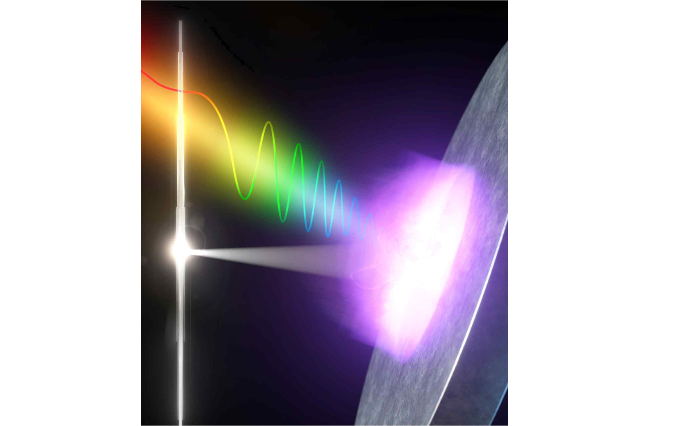▲ Laser pulse compression using plasma: A long laser pulse with a frequency chirp (rainbow colored part) is incident on the plasma (purple bright part) and reflected back, creating a compressed pulse (white bright part) with very high instantaneous output.

The research team solved the compression problem of ultra-strong laser pulses by using plasma instead of diffraction grating. Plasma refers to a gaseous state in which the atoms that make up matter are destroyed and separated into electrons and ions.

Since plasma, which is in an ionized state, is already a damaged material, no further damage occurs no matter how strong the laser beam is, and it also has the property of dispersing light optically. Therefore, by using plasma, it is possible to compress laser pulses into much more powerful laser pulses than existing diffraction gratings.

The research team proved through simulation and theoretical research that using plasma with a spatially specific density distribution can significantly compress laser pulses, similar to diffraction grating.

GIST Professor Hyyong Suk said, "The plasma can act as a conventional diffraction grating and is a non-damaging material, overcoming the shortcomings of existing technologies. Plasmas as small as a few centimeters could be used in ultra-powerful lasers of more than an exawatt (1 exa = 10¹⁸)."

UNIST Professor Min Sup Hur said, "This work shows a new way to overcome the limitations of the ideas of Professor Mourou, who won the Nobel Prize in Physics in 2018, and could be used in basic sciences such as cutting-edge astrophysics, as well as in industrial and energy research such as laser nuclear fusion."

The results of this study are expected to be used to implement various phenomena predicted in cutting-edge theoretical physics and astrophysics in the laboratory. It is expected that it can be used in laser nuclear fusion research and become a cornerstone in solving the energy problems facing humanity.

This research, conducted in close cooperation between GIST Department of Physics and Photon Science Professor Hyyong Suk's team, UNIST Department of Physics Professor Min Sup Hur's team, and University of Strathclyde Department of Physics Professor Dino Jaroszynski's team, was supported by the Ministry of Science and ICT/National Research Foundation of Korea and UKRI/United Kingdom Science and Engineering Research Council and was published online on November 13, 2023, in Nature Photonics, a top 1% paper in the field of optics and applied physics.



