Professor Youngjune Park's research team develops eco-friendly ESS (Energy Storage System) source technology... Realizing carbon neutrality by maximizing natural gas and hydrogen storage

- Professor Youngjune Park’s research team discovered the correlation between the main factors of the ‘tuning effect’ that maximized gas hydrate-based energy gas storage using water
- Expected to be used as an eco-friendly material for storing energy gases such as hydrogen and natural gas

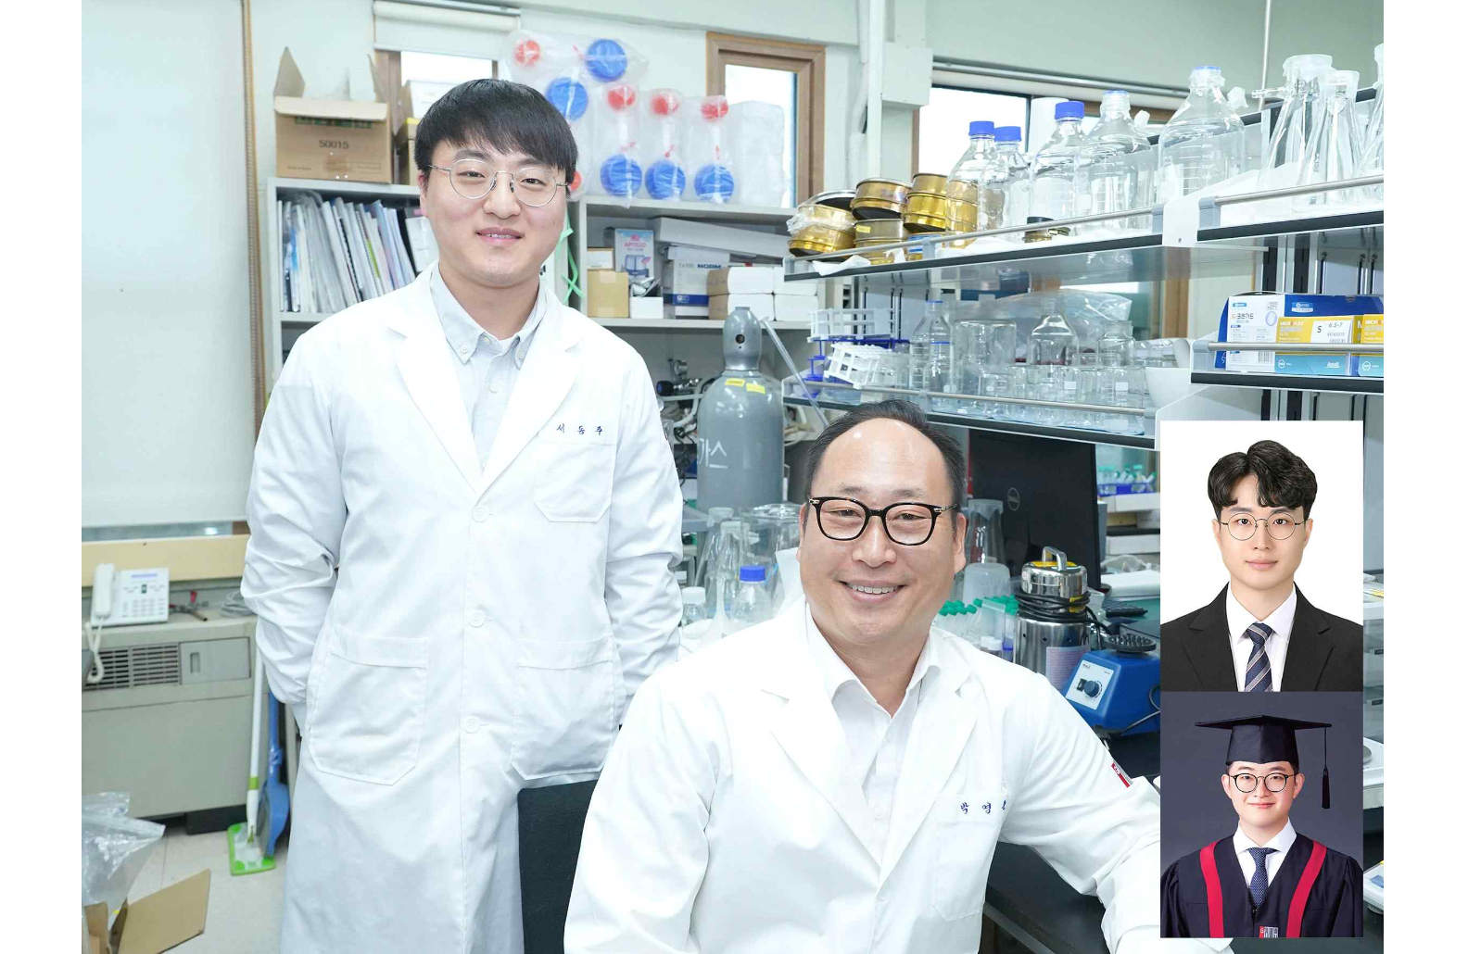▲ Doctoral student Dongju Seo, Professor Youngjune Park, (above) Dr. Yunseok Lee, (below) doctoral student Seungin Lee

Recently, interest in and demand for clean energy to achieve carbon neutrality has increased significantly around the world. In particular, ‘gas hydrate’ is attracting attention as an alternative energy source and solution to environmental problems.

The Gwangju Institute of Science and Technology (GIST, President Kichul Lim) announced that Professor Park Youngjune's research team in the School of Earth Sciences and Environmental Engineering has developed gas hydrate source technology that can maximize the storage of energy gases such as natural gas and hydrogen.

Gas hydrate*, which is made from water and gas, is an eco-friendly material and has a wide range of industrial applications, including gas storage and separation. In particular, when used as a natural gas storage medium, it is attracting attention as a next-generation energy storage medium to prepare for global warming because it can store natural gas at room temperature and lower pressure conditions than liquefied and compressed natural gas technology.

* gas hydrate: refers to a crystalline solid compound in which gas molecules are physically trapped inside a three-dimensional crystal lattice created by water molecules through hydrogen bonding under low temperature and high pressure conditions.

To alleviate the gas hydrate formation conditions under low temperature and high pressure conditions, a thermodynamic formation accelerator* can be used at a stoichiometric* concentration. At this time, a problem arises where energy gas occupies part of the nanolattice space where it can be stored, reducing the amount of gas stored in the hydrate.

* thermodynamic formation accelerator: A formation accelerator that can alleviate the thermodynamic formation conditions of gas hydrate at low temperature and high pressure to room temperature and low pressure.

* stoichiometric: The number of moles of thermodynamic promoter required to occupy all of the large cavities (16 per unit cell) of the hydrate. For structure II hydrate, the stoichiometric concentration of thermodynamic promoter is 5.56 mol%.

To solve this problem, the research team selectively adjusted the concentration of the thermodynamic formation accelerator to empty some of the nanolattice space of the hydrate and fill it with gas molecules. It was suggested that the ‘tuning effect’, which can improve gas storage by alleviating thermodynamic formation conditions, can be usefully utilized.

The tuning effect is a very effective approach for storing natural gas and hydrogen energy, which is a next-generation alternative energy source. This can be induced by some of the large pores in the hydrate lattice being occupied by thermodynamic formation accelerator being occupied by gas molecules. By relieving the extreme formation conditions, which is a problem with gas hydrate technology, and at the same time overcoming the limitations of limited storage amount, the storage amount of gas can be greatly improved.

In addition to the previously identified energy gases such as methane and hydrogen, the team also induced tuning effects for carbon dioxide for the first time and made the world's first discovery of tuning effects in structures I and II for carbon dioxide and structure H* for methane.

* Structure I, II, H: The characteristic crystal structure of gas hydrate determined by the size and shape of the molecules trapped in the pores of the gas hydrate.

In order to apply this tuning effect to industry, the research team utilized a thermodynamic formation accelerator to extend the concept of the tuning effect studied in existing ice-based gas hydrates to water-based hydrates that are advantageous for mass production, and the correlation between key factors such as eutectic melting point* and hydrate conversion rate to induce tuning effects was identified.

* Eutectic point: The constant point at which a solid mixture of two or more components is completely dissolved and mixed in a liquid state without forming a solid solution.

As a result, for ice-based hydrates, a tuning effect was induced in all cases where thermodynamic formation accelerator were used at substoichiometric concentrations. It was confirmed that the tuning effect was induced in the water-based hydrate only when the concentration of the thermodynamic formation accelerator was used below the eutectic point.

Meanwhile, to achieve a high tuning effect, the concentration of the thermodynamic formation accelerator must be low. In this case, the conversion rate of the hydrate is also low, resulting in a relatively low gas storage amount despite inducing a strong tuning effect.

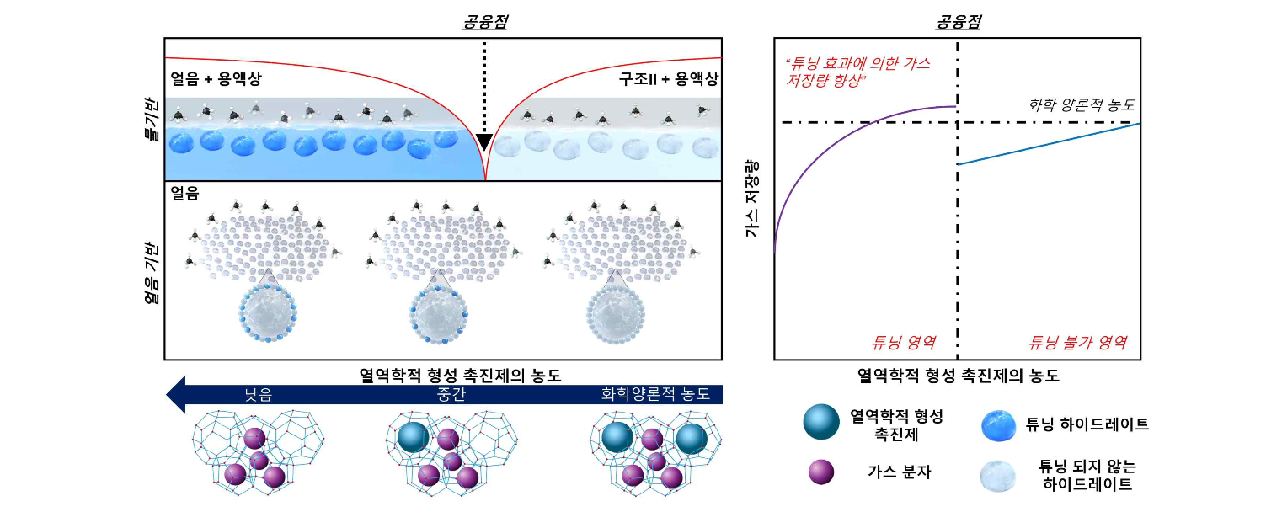▲ Schematic diagram of gas storage improvement mechanism due to eutectic point and tuning effect in gas hydrate: In order to induce tuning effect from water-based hydrate, the concentration of thermodynamic formation accelerator must be used under conditions below the eutectic point, which will ensure a high conversion rate. When used in a high concentration region near the eutectic point, substantially improved gas storage can be secured due to the tuning effect.

The research team used thermodynamic formation accelerators at a concentration below the eutectic point but formed hydrates at a concentration close to the eutectic point. It was confirmed that the gas storage capacity of the hydrate with the induced tuning effect was significantly improved compared to the hydrate formed at a stoichiometric concentration.

Through this, it was confirmed that the optimal concentration of the thermodynamic formation promoter to overcome the trade-off between hydrate conversion rate and tuning effect is the adjacent concentration region below the eutectic point. It was confirmed that it is advantageous to use a thermodynamic accelerator with a high eutectic point in order to obtain a high conversion rate.

Professor Youngjune Park said, "In order to maximize the energy storage of gas hydrate, which can secure high energy density when used as an energy gas storage medium, original technology was secured by utilizing the tuning effect. This research outcome is expected to provide high competitiveness in the upcoming hydrogen energy era."

This research, led by GIST Professor Youngjune Park and conducted by Dr. Yunseok Lee, PhD student Dongju Seo, and PhD student Seungin Lee, was conducted with support from the National Research Foundation of Korea's mid-career individual basic researcher support project and was published online in Accounts of Chemical Research, a renowned academic journal within the top 5% in the field of chemistry, and Chemical Engineering Journal, a renowned academic journal within the top 5% in the field of chemical engineering, on November 7 and October 1, 2023, respectively.



