“Semiconductor, the era of infinite copying is coming” GIST-MIT, commercialization of ‘remote epitaxy’

- Prof. Dong-Seon Lee’s joint research team produces gallium nitride semiconductors as if copying them… expected to significantly reduce unit cost
- Inserting a graphene film between the wafer and the semiconductor material... removing only the semiconductor material and reusing the wafer

▲ (From left) School of Electrical Engineering and Computer Science doctoral student Hoe-Min Kwak Kwak and Professor Dong-Seon Lee

GIST (Gwangju Institute of Science and Technology, President Kichul Lim) School of Electrical Engineering and Computer Science Dong-Seon Lee’s team developed ‘gallium nitride* remote epitaxy’ technology through a metal organic chemical deposition method only through joint research with the Massachusetts Institute of Technology (MIT). With this technology, gallium nitride semiconductors can be grown** on a wafer and then easily removed, enabling continued production as if copying semiconductors from a single wafer.

* gallium nitride (GaN): A common semiconductor material used to make LEDs. It is also used for lasers, transistors, etc., and has recently attracted great attention as a gallium nitride power semiconductor required for electric vehicles.

** growth: As a semiconductor term, it means growing a thin crystalline layer on a wafer through physical and chemical methods.

The structure of a semiconductor largely consists of a wafer and a semiconductor material. Just as you can build a building (semiconductor material) on a foundation (wafer) when you build a building, you need silicon and silicon carbide to grow high-quality semiconductor material. Wafers made of sapphire or the like are essential. Semiconductor materials are made on these wafers by epitaxial technology, which grows thin films of the same or similar materials in highly ordered shapes.

However, with the existing epitaxy technology, it took about 1,000 times a 1mm thick wafer to obtain a semiconductor material with a thickness of about 1μm (micrometer). It was very difficult in terms of technology and cost to remove and use only semiconductor materials that are actually used.

The ‘remote epitaxy’ technology first proposed by Professor Jihwan Kim of MIT in 2017 is a unique technology that places a very thin two-dimensional material such as graphene on a wafer and grows a semiconductor material on top of it. It is possible to obtain high-quality semiconductor material in the form of a thin film that 'copied' the characteristics of the wafer as it is, and even 'separate' it from the wafer, theoretically allowing the wafer to be reused infinitely.

This technology is based on the principle that the electrical characteristics of the wafer surface penetrate the graphene film, and since the semiconductor material is not directly bonded to the wafer, only the semiconductor material can be separated. It is similar to the phenomenon that if you put paper (graphene film) on a bar magnet (wafer) and sprinkle iron powder (semiconductor material) on it, the iron powder does not directly attach to the bar magnet but gathers at the anode with the paper in between.

In particular, gallium nitride semiconductors, which are widely used in LED displays and electric vehicle chargers, are most efficient when gallium nitride wafers are used. Since the price is about 100 times more expensive than sapphire wafers, sapphire wafers with a crystallinity of only one-thousandth level have been used. Accordingly, great expectations were gathered for remote epitaxy technology that can reuse expensive gallium nitride wafers.

However, when remote epitaxy technology is applied under high-temperature growth conditions such as the ‘metal organic chemical vapor deposition*’ method mainly used in the industry, it was judged to be impossible to apply because the surface of the gallium nitride wafer is decomposed and the graphene film is damaged.

* metal-organic chemical vapor deposition: A process of growing a semiconductor thin film using a metal-organic compound. The metal-organic compound precursor is evaporated and delivered to the wafer in a gaseous state, and through a chemical reaction in the deposition device It is converted to a solid and grown as a thin film on a wafer.

By introducing an ‘aluminum nitride (AIN)’ wafer with similar characteristics to gallium nitride, the research team succeeded in realizing a remote epitaxy technology that grows and peels a gallium nitride thin film using only the ‘metal organic chemical vapor deposition’ method.

This research has opened a way to produce highly crystalline and expensive gallium nitride semiconductors at industrial sites through remote epitaxy technology. In fact, when applied to semiconductor production, high-quality semiconductor materials can be mass-produced at a very low price. Furthermore, since only semiconductors grown in the form of a thin film can be removed and used, various semiconductors with various functions can be stacked in the same narrow space.

In addition, the team also identified the “non-peelable mechanism” in which the gallium nitride semiconductor cannot be removed from the wafer because the graphene film is damaged when there are nano-sized scratches on the aluminum nitride surface.

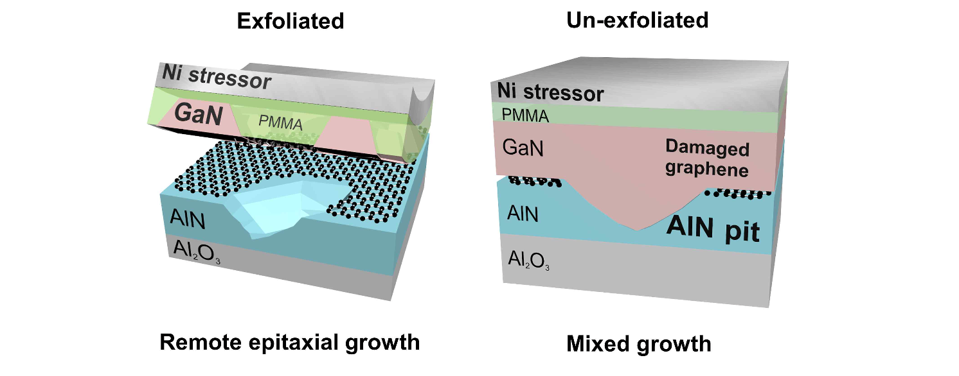[Picture 1] Schematic diagram of whether gallium nitride grown by remote epitaxial growth and mix growth methods is exfoliated. In the case of gallium nitride grown only by the remote epitaxial growth method, exfoliation is possible without being affected by nano pits (scratches), but gallium nitride grown by the mix growth method is directly bonded to the nano pits and cannot be exfoliated.

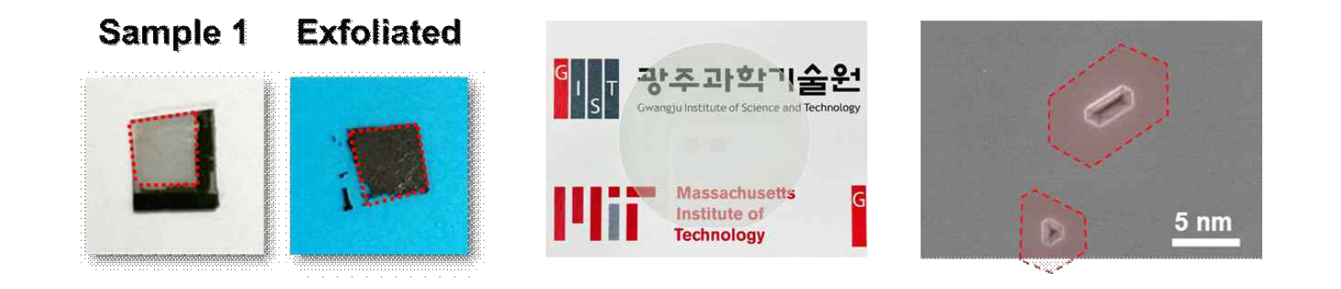[Figure 2] Exfoliation image of gallium nitride grown by the remote epitaxy method, the actual used AlN template wafer, and an electron microscope image magnified 50,000 times of the AlN template wafer. For samples with perfect remote epitaxy technology, exfoliation through the nickel stressor works well. In the case of actual used wafers, the wafers look very transparent and smooth to the naked eye, but nano-sized pits exist when observed under magnification through an electron microscope, which acts as an obstacle to the application of remote epitaxy technology. (The red border area in the electron microscope image is the area where the 2D material is actually damaged during the remote epitaxy process, and corresponds to the area 9 times the nanopit)

Previously, there were often studies that imitated the remote epitaxy technology and only ‘copied’ the semiconductor material without revealing whether it was ‘exfoliated’. With this study, for the first time, it was clarified that ‘exfoliation’ is an essential condition in remote epitaxy technology.

GIST Professor Dong-Seon Lee said, "With this research result, it was possible to suggest a method and essential conditions for implementing the ‘gallium nitride remote epitaxy’ technology that can even be peeled off. Through continuous research exchanges with MIT, we will develop semiconductor super-difference technologies such as remote epitaxy technology."

Since 2019, Professor Lee has continued joint research with Professor Jihwan Kim of MIT and is accelerating the securing of next-generation semiconductor technology to preoccupy the global market.

The research, led by Professor Lee and conducted in collaboration with MIT with Ph.D. student Hoe-Min Kwak and was supported by the Nano and Materials Technology Development Project of the Korea Research Foundation of the Ministry of Science, ICT and Future Planning and the Individual Research Project (mid-level research) and was published on June 6 in ACS Nano, a prestigious international journal in the field of materials science and chemistry.



