“Finding a new clue to the treatment mechanism of depression” GIST-Caltech jointly develops therapeutically effective substances

- Development of substances that selectively inhibit depression-inducing receptors, published in the international journal 「JMC」
- Acts as a new mechanism... Expected to apply to patients who are not currently receiving treatment

▲ GIST School of Life Sciences Professor Yong-Chul Kim and Ph.D. student Jae-Hoon Jung

The proportion of patients with depression is increasing rapidly in Korea. Currently used drugs, ‘selective serotonin reuptake inhibitors (SSRIs)’*, take a long time to see an effect and are even ineffective in some patients, so it is necessary to develop a candidate drug with a different mechanism.

* selective serotonin reuptake inhibitors (SSRIs): Drugs that increase the amount of serotonin by selectively inhibiting the reuptake of serotonin, a neurotransmitter with antidepressant action, to enhance its action. Used for depression, panic disorder, anxiety, disabilities, etc.

GIST (Gwangju Institute of Science and Technology, Acting President Raekil Park) School of Life Sciences Professor Yong-Chul Kim's research team developed 'KOR b-Arrestin inverse agonist', which will be a clue to a new antidepressant drug, together with Professor William Goddard's research team at Caltech (California Institute of Technology) in the US.

* KOR (Kappa Opioid Receptor): Kappa opioid receptor. It is one of the opioid receptors that regulate various signal transduction processes related to pain relief and depression in the nervous system.

When exposed to stress or unpleasant stimuli for a long time, the KOR system becomes excessively active, which can cause various mental disorders such as depression. This symptom is closely related to the signal transduction pathway of proteins* that are cascadingly activated as KOR is activated. The research team proposed the development of a drug that reduces the activity of KOR by regulating the detailed sub-mechanism of the receptor.

* p38 MAP kinases (p38 mitogen-activated protein kinases): A type of mitogen-activated protein kinases (MAPKs) that respond to stress stimuli.

The research team succeeded in developing an inverse agonist that potently and selectively lowers KOR activity by designing and synthesizing an optimized compound based on the pyrazoloisoquinoline core skeleton*.

* pyrazoloisoquinoline core skeleton: This is a standard structure for synthesis, and derivatives with various residues introduced are synthesized using this structure.

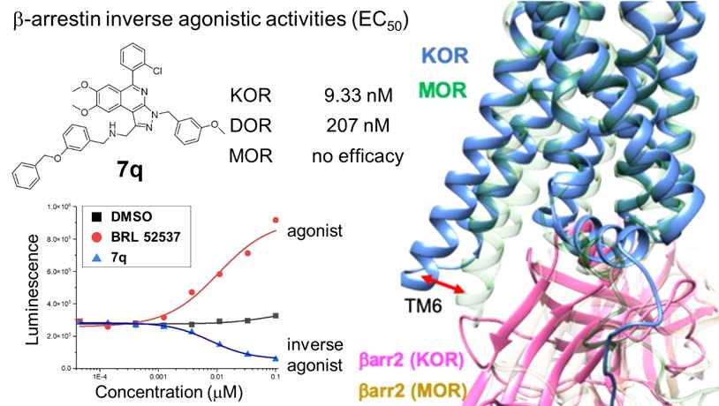
[Figure 1] The inverse agonist effect on KOR b-arrestin was confirmed through activity evaluation, and its mechanism of action was predicted through molecular dynamics simulation.

It was confirmed that this inverse agonist can significantly lower the activity of KOR by significantly inhibiting the binding between KOR and b-arrestin even at a low concentration of several nanomoles (9.33 nM).

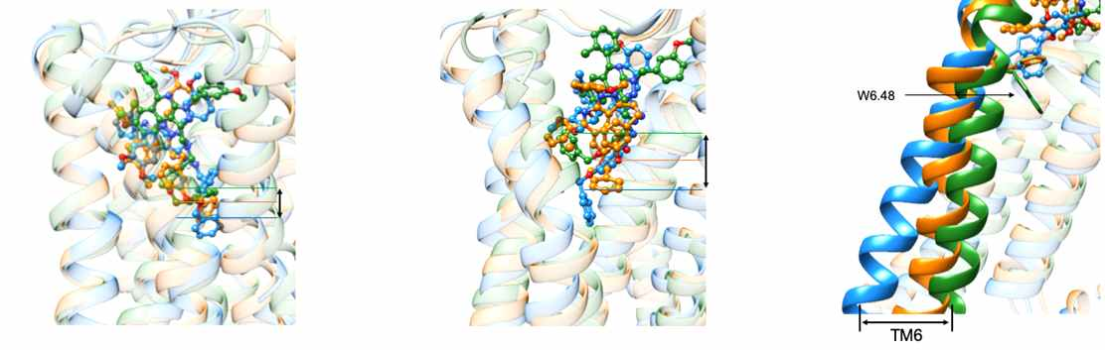
[Figure 2] Through molecular dynamics simulation, when the inverse agonist 7q was bound to Kappa/Delta/Mu Opioid Recpetor and reacted, 7q was deeply bound in the order of KOR/DOR/MOR, and the position of TM6 also greatly changed outward. (KOR: blue, DOR: orange, MOR: green)

The research team focused on the fact that the interaction with b-arrestin varies greatly depending on the position of the 6th helix of the receptor in the state where the drug is bound. In KOR, when an agonist drug that activates the receptor is used, the distance between the 3rd and 6th helices increases. The research team further maximized this distance to induce the opposite effect of inhibiting the binding with b-arrestin.

In particular, the research team was able to confirm the drug's mechanism of action using molecular dynamics simulation and predict the binding mode to propose an adverse mechanism of action.

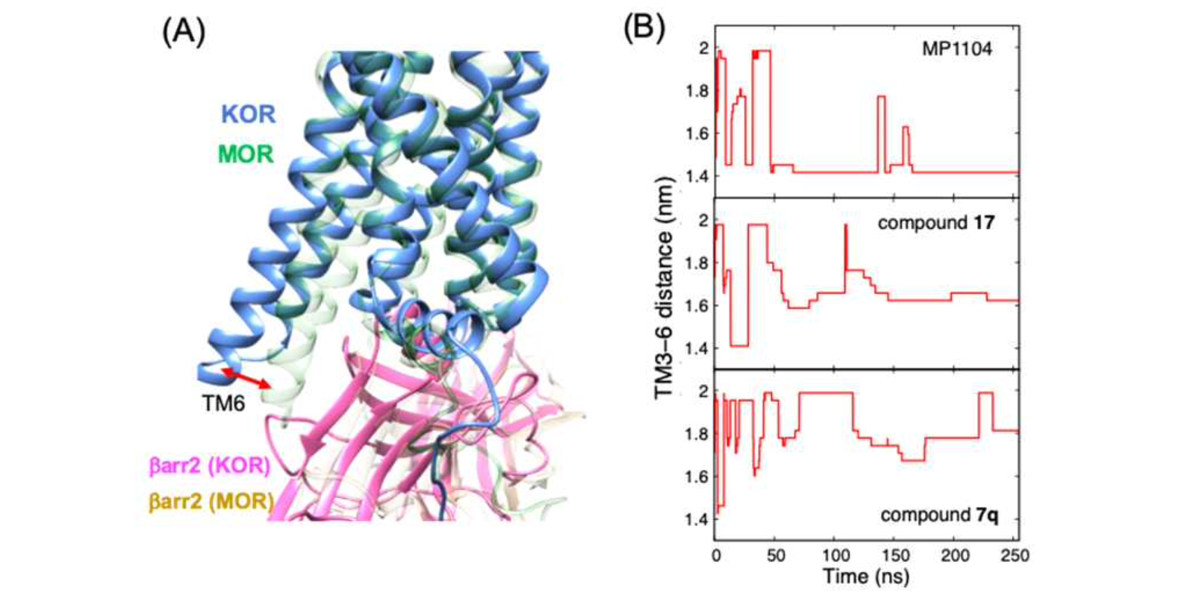[Figure 3] Measure the distance between Transmembrane 3-6 in the ‘Free energy minima’ state over time through metadynamics simulation. The distance between them is predicted to increase in the order of 1.4 nm for MP1104 (agonist), 1.6 nm for compound 17 (neutral antagonist), and 1.8 nm for compound 7q (inverse agonist).

GIST School of Life Sciences Professor Yong-Chul Kim said, "Through this study, we succeeded in developing an inverse agonist that effectively lowers the activity of KOR. It is expected to play an important role in developing new drugs to complement currently used antidepressants."

This research was jointly conducted by GIST Ph.D. student and Caltech post-doctoral researcher Moon Young Yang under the guidance of Professor Kim and Professor Goddard and was supported by a GIST-Caltech joint research project and a GIST researcher project. The research results were published online on April 13 in the Journal of Medicinal Chemistry, an authoritative international academic journal in the field of medicinal chemistry.



