[2019 상반기(3월) 사이버 한국유학박람회 개최 안내]

교육부 국립국제교육원에서는 『2019 상반기(3월) 사이버 한국유학박람회』를 아래와 같이 개최합니다.
1. 행사명: 2019 상반기(3월) 사이버 한국유학박람회
2. 일자: 2019.3.26.(화) ~ 4.8.(월) <2주간>
* 등록: 2019.3.18.(월)~4.8.(월)
3. 주요메뉴소개
o 한국유학안내, 장학금제도, 대학정보, 온라인 입학신청, 온라인 상담, 실시간 상담 등
4. 참가대학: 55개교
5. 접속 및 참가방법(세부사항첨부파일참고)
O 한국유학종합시스템 웹사이트(www.studyinkorea.go.kr)에 접속하여 박람회 링크선택
O 등록(Registration) 후 박람회 기간 중 사이트방문

[The First half of 2019(March) Study in Korea Online Education Fair]
It is our pleasure to announce that NIIED will hold “2019 March Study in Korea Online Education Fair” for international students.
- Name of the event: The First half of 2019(March) Study in Korea Online Education Fair
- Date: March 26th (Tue) ~ April 8th (Mon)
* Registration: March 18th (Mon) ~ April 8th (Mon)
3. Introduction of main contents
- Studying in Korea, Scholarship programs, Information about Korean Universities, Online application, Online consultation, Real-time consultation
4. Participating universities: 56 universities
5. How to access and join the online education fair (Please see the attachment.)
- Visit the Study in Korea website (www.studyinkorea.go.kr) to select the online education fair link.
- Complete the registration and visit the website during the online education fair.
<Attachment>
How to register
“The First half of 2019(March) Study in Korea Online Education Fair”

- Visit the Study in Korea website“www.studyinkorea.go.kr”
- Click The First half of 2019(March) Study in Korea Online Education Fair.
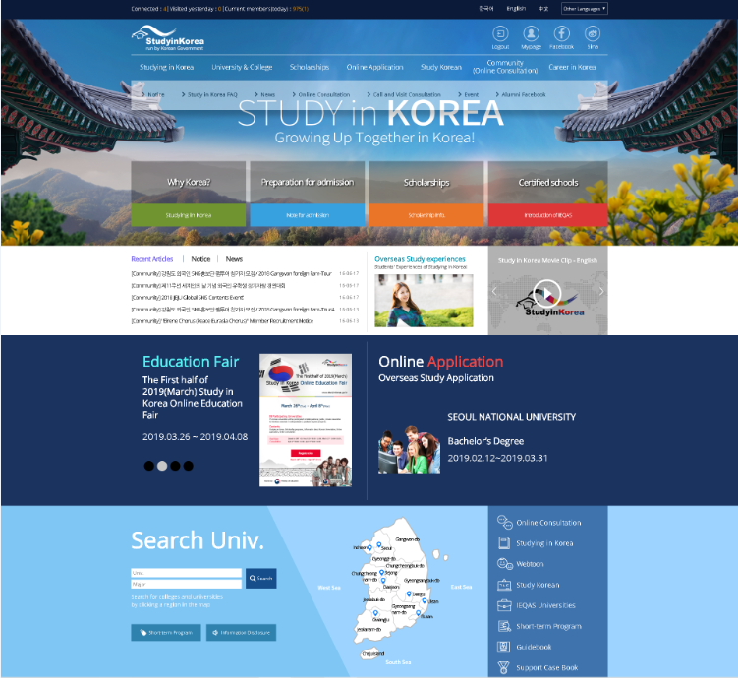
- Click “Registration” to join the Fair. “Registration” is available from March 18th (Mon) ~ April 8th (Mon).
- Please visit the education fair page during the period of March 26th (Tue) ~ April 8th (Mon).

